**1.** **Data Structures for Linear Algebra** 2

**1.1.** **What Linear Algebra Is?** 2

**1.2.** **Plotting a System of Linear Equations** 5

# **Data Structures for Linear Algebra**

## **What Linear Algebra Is?**

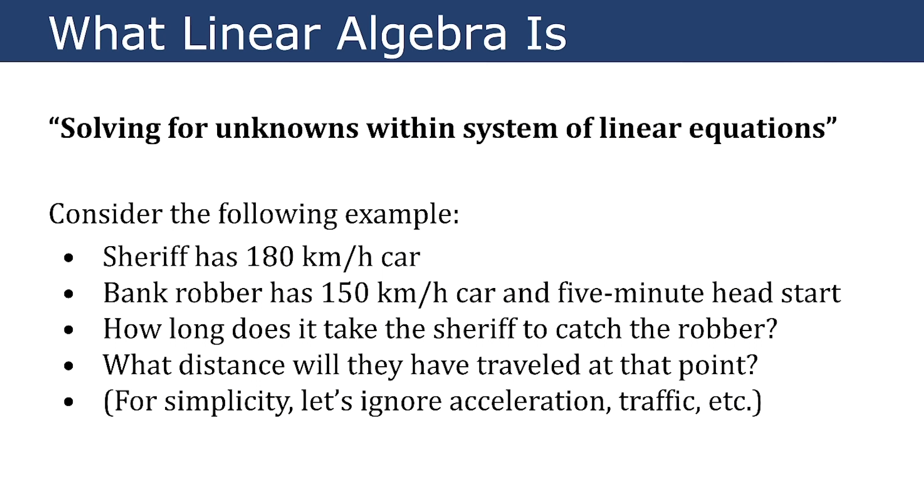

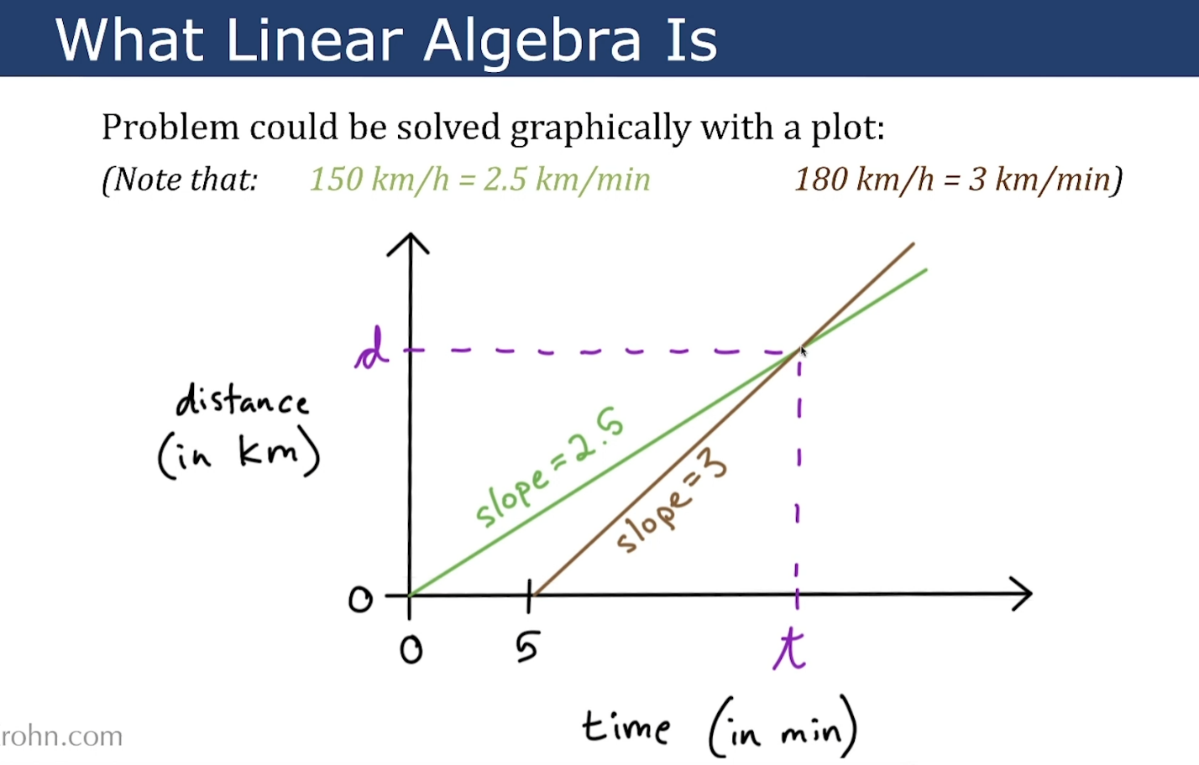

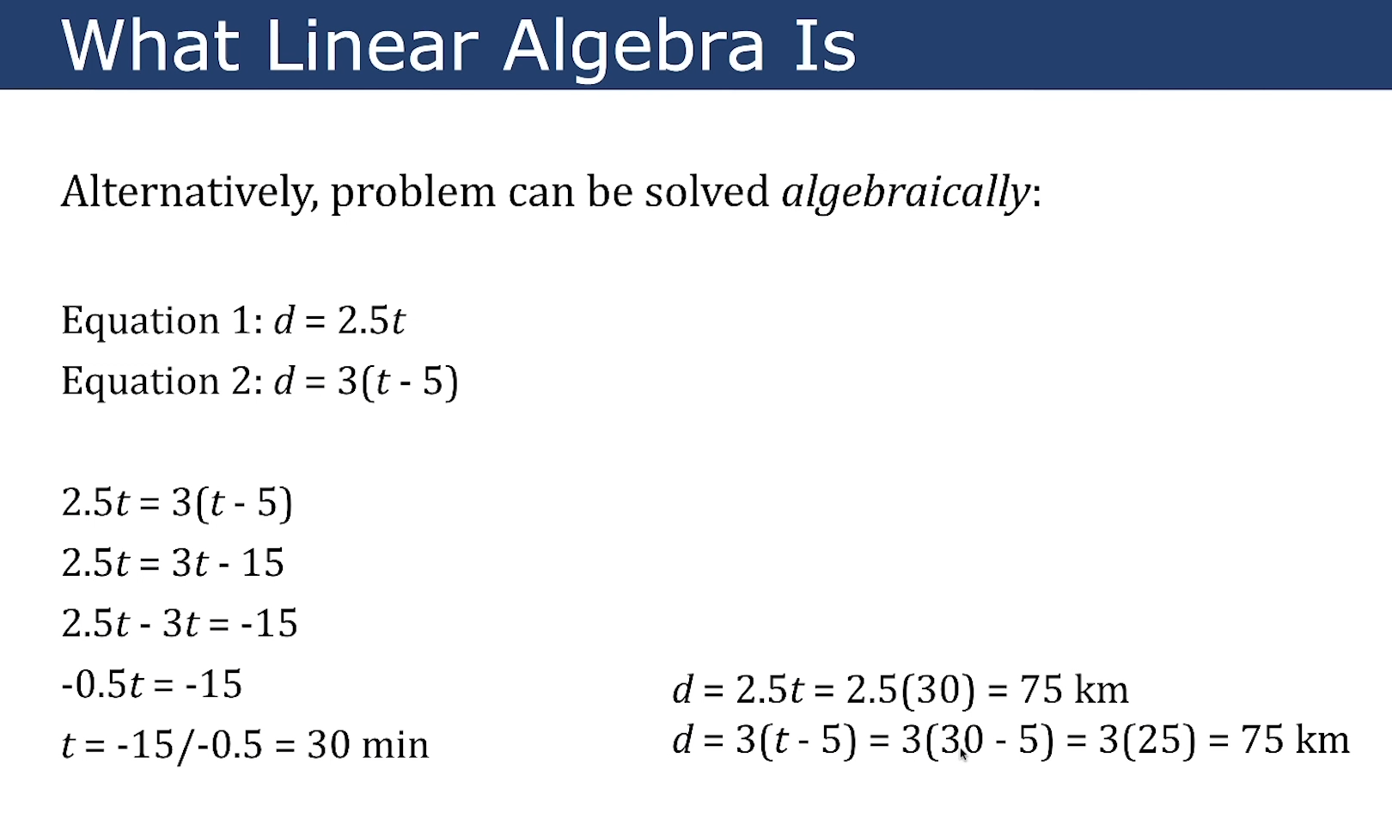

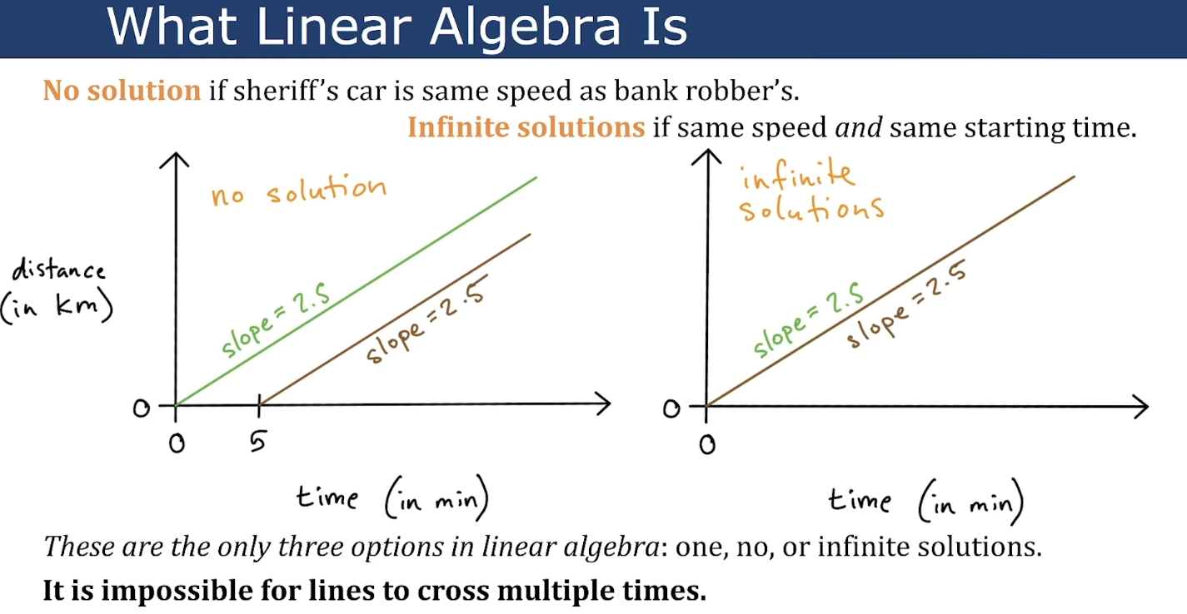

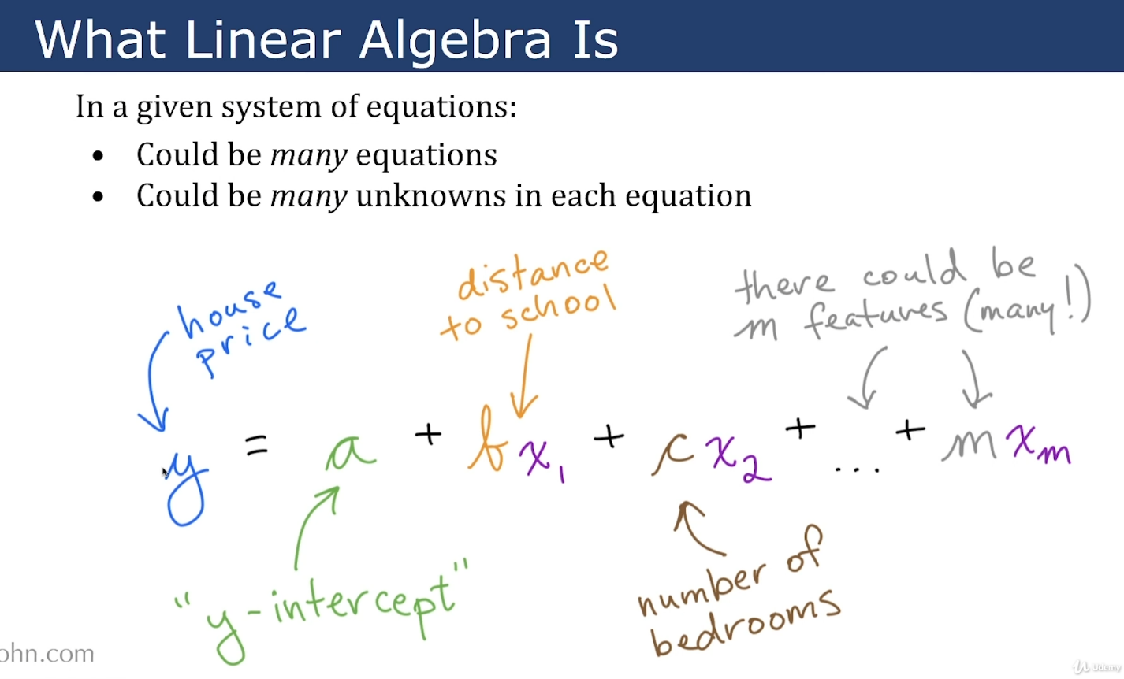

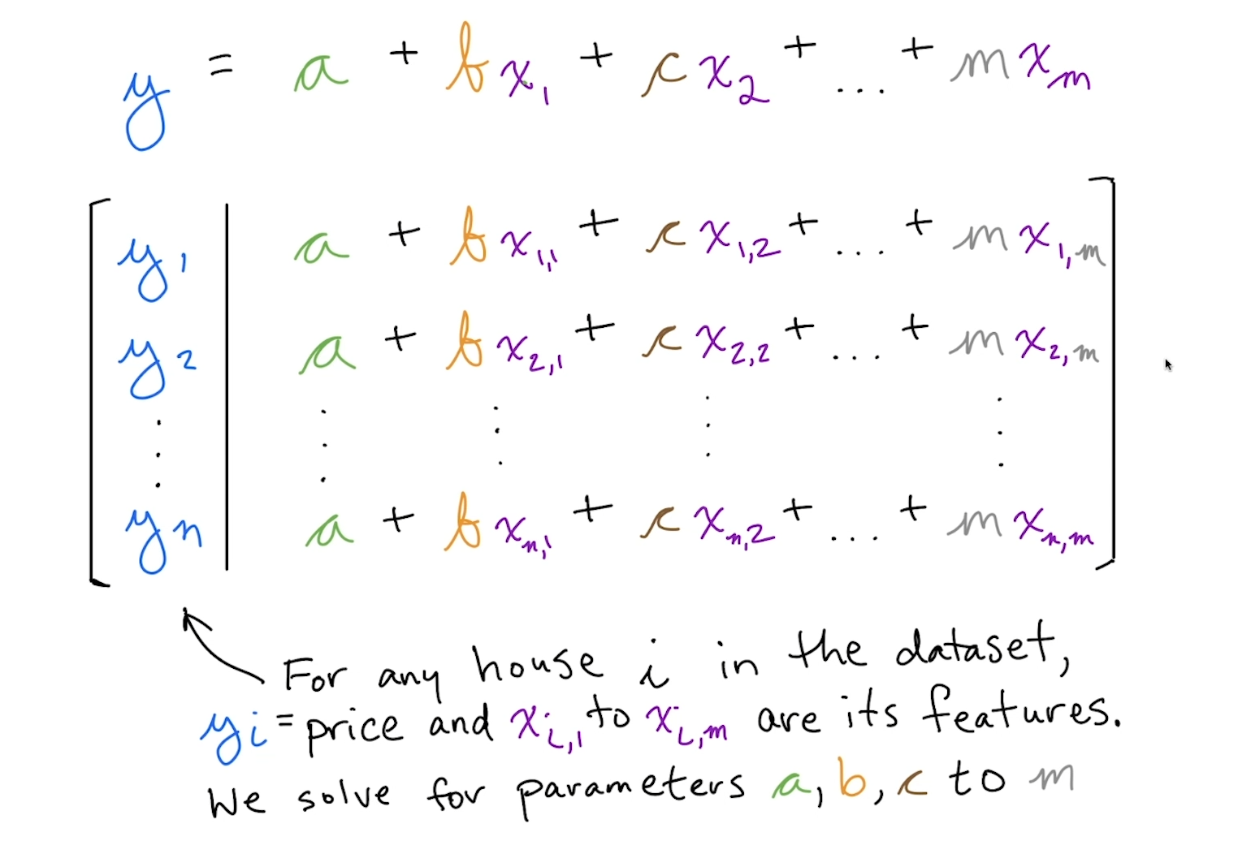

Square brackets is a SET in linear algebra world.

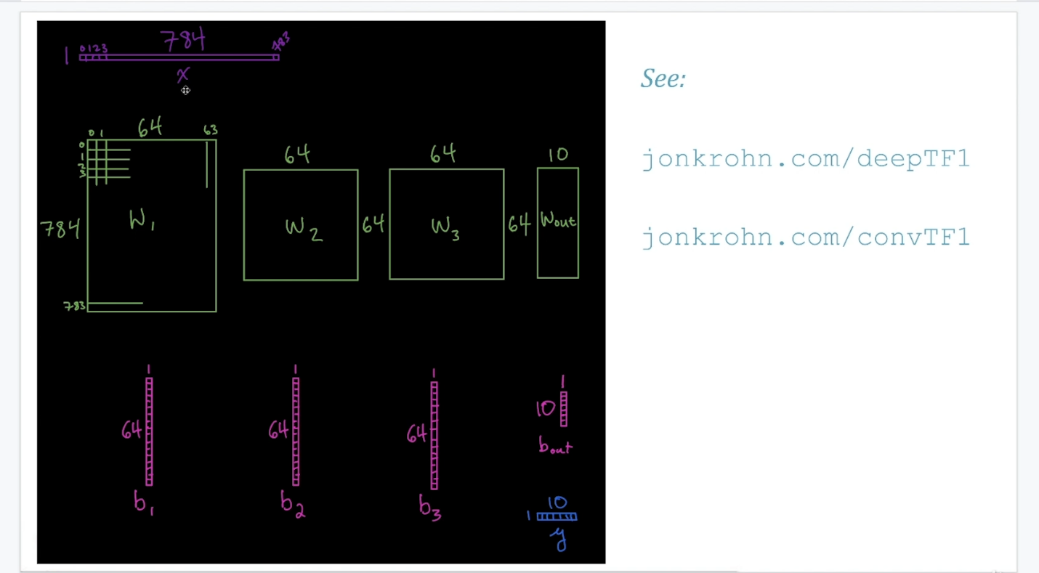

## **Linear Algebra Exercise**

